LEGO The Simpsons Design Doc

Mechanics

Global (applied to all characters)
- Move / Run – Using Left joystick on controller, the input direction makes character move / run in that direction
- Jump – Press (A/Cross/South) on controller, character jumps X height. (Time to complete – 0.1 seconds)
- Double Jump – Double tap (A/Cross/South) on controller, character jumps 2X height. (Time to complete – 0.2 seconds)
- Attack - Press (X/Square/West) on controller, character animates attack, causes X damage to NPC in range. (Time to complete – 0.3 seconds)
- Ground Slam – 'Jump' then press (X/Square/West), character jumps then animates a falling attack. Damages NPC in Y range in front of player (Time to complete – 0.6 seconds)
- Super Slam - 'Jump' then press (X/Square/West), character jumps then animated a larger falling attack. Damages all NPC's with in Y Range around the player (Time to complete – 0.8 seconds)
- Build-it – Break props apart, the remaining pieces hop to a position, player stands at that position, button prompt appears, hold (B/Circle/East) to put LEGO pieces together.
- Tag – Tapping (RB/R1) tags the player to the next character to control, and tapping (LB/L1) tags the player to the previous character. Holding either button brings up the game wheel to allow players to select a specific characters when more than one is available
- Push Block – LEGO objects can be pushed along LEGO "tracks", Either the object or the track can sometimes need to be assembled

Specialized (Character Specific)

Homer
- Eat - Standing near editable props, button prompt appears, hold (B/Circle/East) to destroy obstacle / props. Can clear paths or reveal hidden items or interaction points (Time to complete – 2.2 seconds)
- Uranium Switch - Press(B/Circle/East) when standing next to a switch socket, Homer equips a uranium rod and places into the switch socket and uses it as a handle and pulls the new lever down, Requires Uranium rods which can be collected from various locations in the level (Time to complete – 1.8 seconds)
- Uranium – homer is the only one who can pick up the Uranium Rob objects. Press(B/Circle/East) when standing next to a Rod to equip a pair of tongs and collect the item, multiple Rod's can be collected and are stored in an "inventory", not in the characters hands.

Bart
- Projectile - Hold (X/Square/West) to bring up a targeting reticle, Bart equips his slingshot and pulls it back, ready to fire. Moving the reticle over any target locks the aim, up to 5 targets can be locked onto at any point, Releasing (B/Circle/East) fires the projectile and any selected target.
- Agility - Tapping (A/Cross/South) when near pipes, horizontal poles or ledges allows Bart to climb and navigate difficult paths that other characters can't.
- Paint - Hold (B/Circle/East) When at starting point to paint yellow lines on the floor. These continue from line throughout the level that robots follow. The lines are predetermined. Any other paths are broken in the process forcing robots to follow the new line.
- Small Access - Press(B/Circle/East) when standing next to a vent, character crawls through the hatch, camera changes to show the network of vent and the player must navigate to another connected hatch.

Lisa
- Laser Pen - Hold (X/Square/West) to bring up a targeting reticle, Lisa equips a laser pen and points where the reticle is aiming. Can be used against robots to stun them for 2 seconds. Can also be used to power switches (contact must be maintained for switch to be active).
- Hack / Access - Hold (B/Circle/East) when standing near a computer to "Hack" it, The camera is overlayed with the "hacking screen". Computers can open doors and operate machinery. (illustration below)
- Maths - Hold (B/Circle/East) when standing near a whiteboard with equations on to find items
- Small Access – Press (B/Circle/East) when standing next to a vent, character crawls through the hatch, camera changes to show the network of vent and the player must navigate to another connected hatch.

Mr. Burns
- Trap Door - Hold (B/Circle/East) to bring up a target reticle, Mr Burns uses a tablet computer to control "trap doors" or systems in the power plant. Only one trap door or system can be used at a time
- Dogs - Hold (B/Circle/East) To summon a pack of hounds that will attack enemies for 5 seconds, has a

Smithers
- Maths - Hold (B/Circle/East) when standing near a whiteboard with equations on to find items
- Hack / Access - Hold (B/Circle/East) when standing near a computer to "Hack" it. Computers can open doors and operate machinery.
- Remote-Car – Hold (X/Square/West) to deploy a small remote controlled Malibu Stacy car that is navigated with the left (movement) stick.

Level Design

The level makes use of orbital camera controls, allowing players to view the level in all three dimensions.

Stage 1 – Homer's Office
- Intro Cutscene – Showing Homer, Lisa and Bart in homer's office. The power plant going into lockdown as Mr. Burns is kicked out of his office and locked away as the robots take over the power plant. The three have to find a way out of the office, and they notice the hatch to the vent which is currently locked.
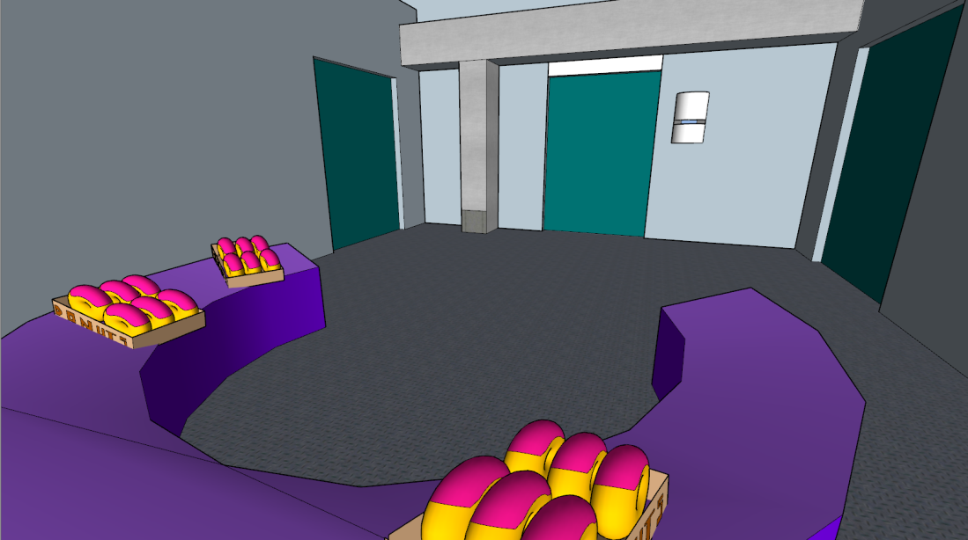
- Homer heads over to the donuts on his desk stating the key was "...around here somewhere."
- Homer is used to Eat the boxes of food.
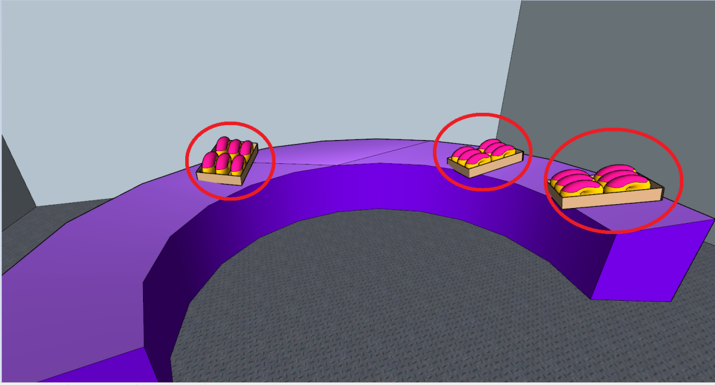
- Player (homer) finds the key after eating the food.
- Player then uses the key to unlock to hatch (stand near and press B)
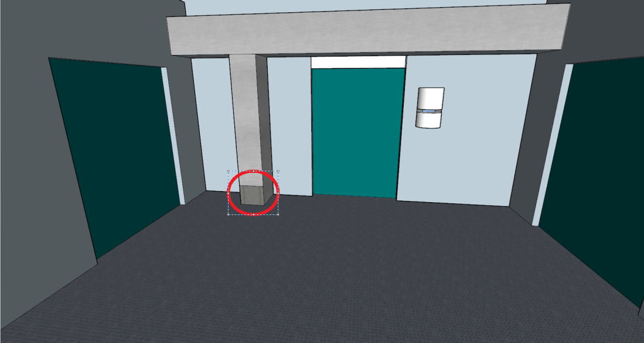

- Player can now tag to either Bart or Lisa who can crawl into the vent
- Upon entering the vent the camera adjusts to black out the "outside" of the vent and show the inside.
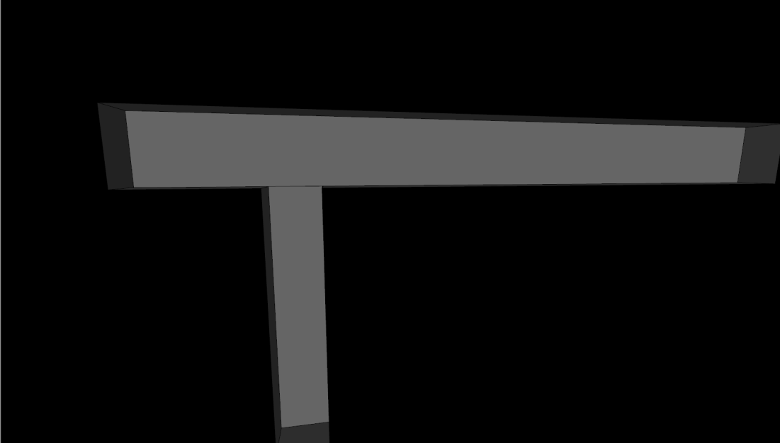
- The character can control the character through the vents and pick their direction
- The "left" vent exit is currently blocked by a machine "arm"
- The right vent is open
- The player must move the character along the vent to the exit to the right
- Once dropped into the next room, the player can stand on a pressure plate to open the door, the door only remains open when the pressure plate is stood on.
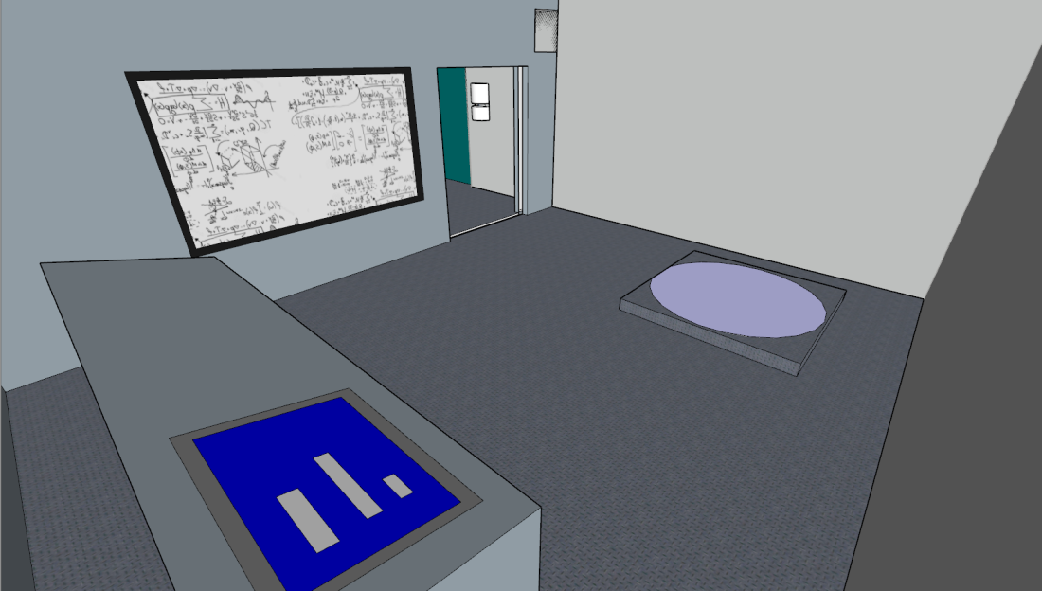
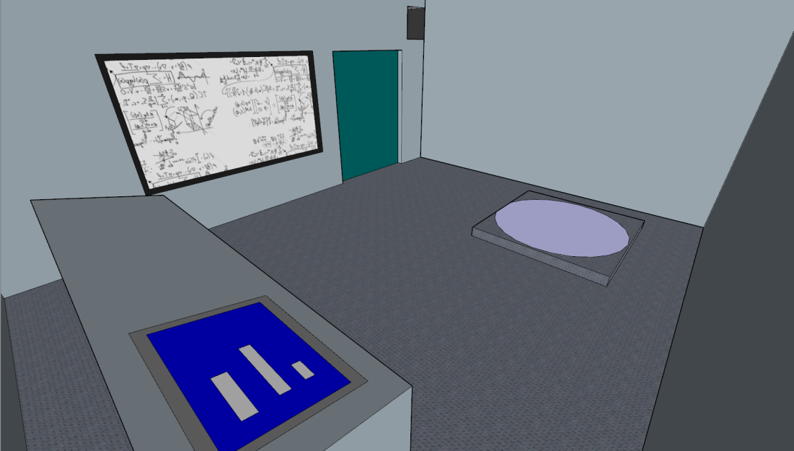
- Player must tag to Lisa and interact with the Whiteboard (Maths) to understand the systems
- Once Lisa has read the board, she can use the computer to "hack" the machinery.
- Upon hacking the camera changes to the "Hack" screen.
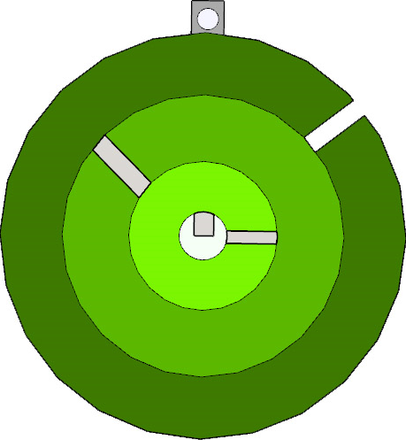
- The player can now use the "left" and "right" controls to rotate the circles, and "up" and "Down" to select each circles.
- The goal is to align the gaps in the gaps to allow a "ball" to fall to the center.
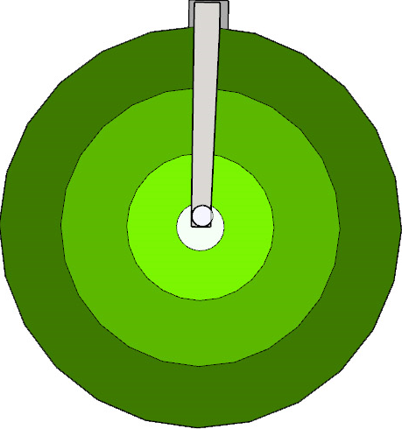
- Once the "ball" has dropped into the center the "hack" is complete
- The "Left" exit of the vent is now opened
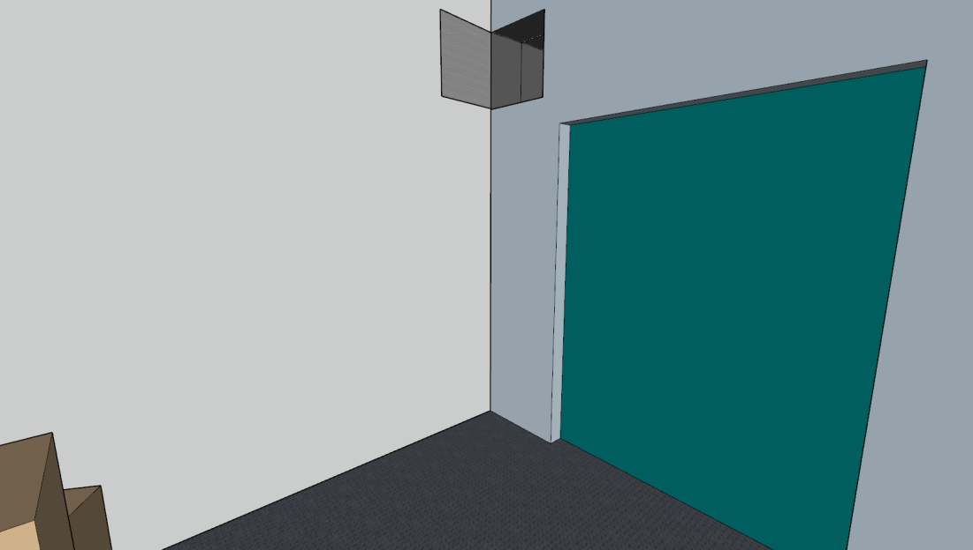
- The player now tags to Bart and enters the vent, moves up and to the left exit of the vent and drops into the storage room.
- Breaking the storage boxes (props) reveals Build-it pieces
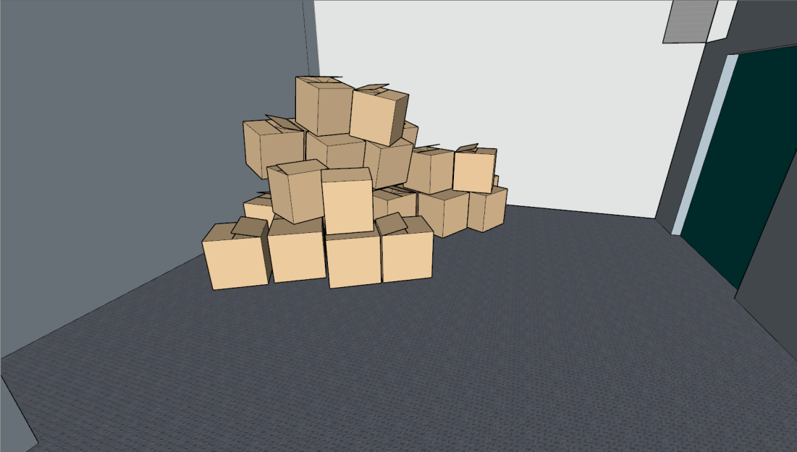
- The Build-it creates another pressure plate.
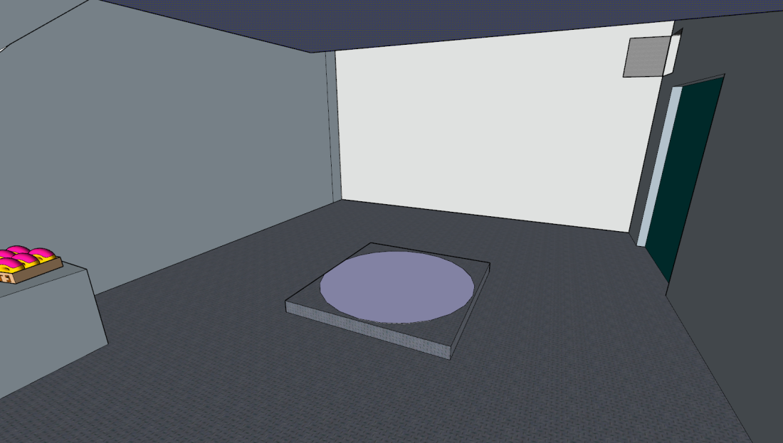
- Using Bart, the player can now use his "slingshot" to target the support of a shelf in the room
- Breaking the support the shelf falls to the ground and drops more boxes (props).
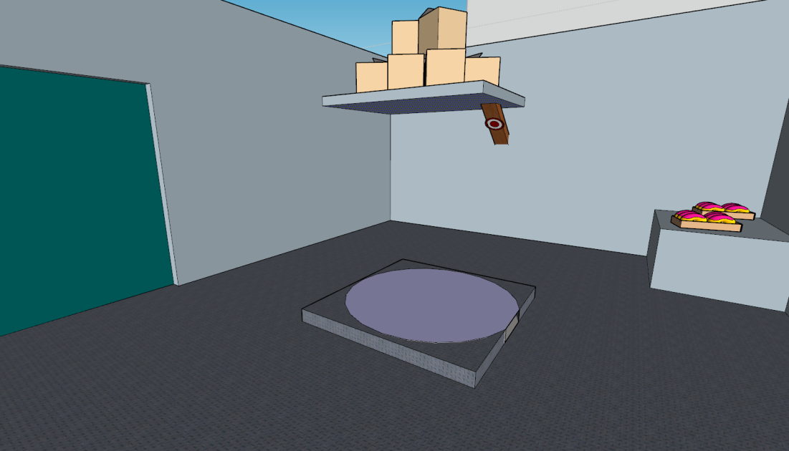
- Smashing the props reveals more Build-it pieces, assembling this Build-it forms a laser panel.
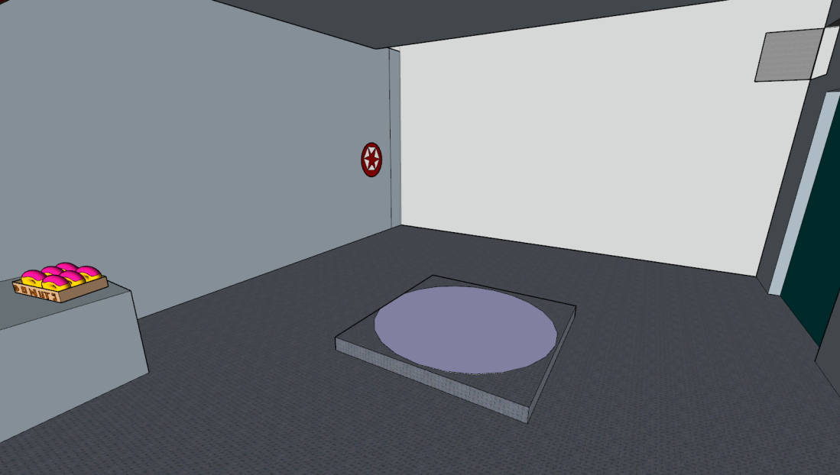
- Moving a character onto this plate will open the door to this room
- Homer can then enter the storage room and eat the food in the corner.
- Once the food has been eaten, a Uranium Rod is picked up by homer.
- Both Pressure plates need to have a character on them in order to open both doors.
- Lisa must stand on one of the pads and use her Laser Pen to target the Laser panel on the wall in the storage room.
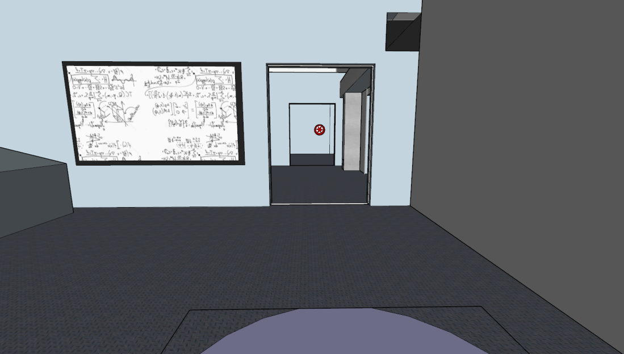

- When the Laser Pen makes contact with the Laser Panel, the security over-ride cover separates near the main door. Allowing homer to interact with it.
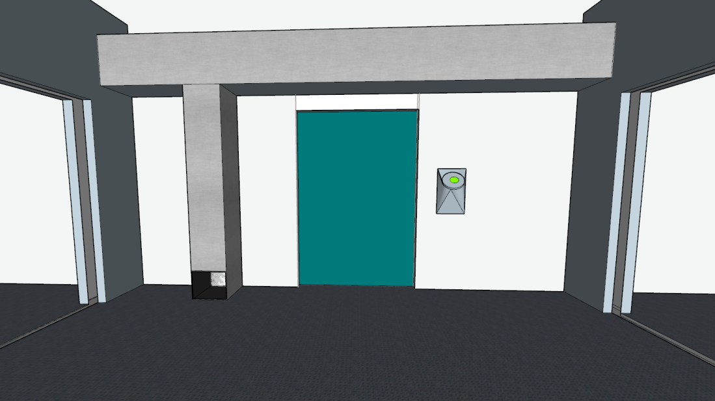
- The Player must now use Homer and the Uranium Rod to active the Uranium Switch
- All 3 doors are now locked open, allowing the player to move out into the hall.

Stage 2 – Hallways
- Mini-cut plays as the player moves out into the hallway, illustrating the yellow lines on the floor and the approaching group of robots. The group agree they need to stop the robots.
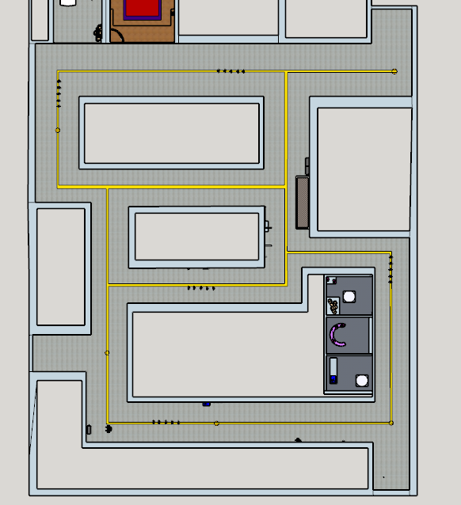
- This section is open for the player to move about freely. As the player is navigating the halls, groups of robots are patrolling along the lines. When they spot the characters they attack. While all (yellow) doors are unblocked the patrols keep spawning every 30 seconds, one door at a time, in series. There is only ever a maximum of 6 patrol groups.
- When a (yellow) door is either blocked off, or the robots from that door are prevented from patrolling, the total number of patrols is reduced.
- When all doors are blocked the player can go and free Mr. Burns and Smithers. Attempting to do so before the robots doors are complete results in the two trapped characters stating they do not want to leave "...whilst those stupid robots are still out there!"
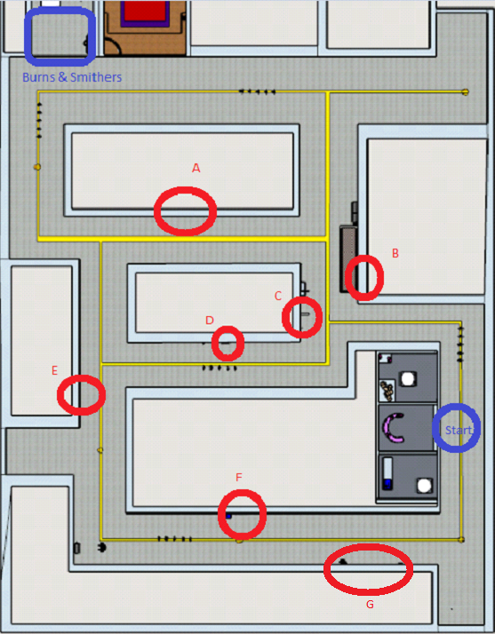

- Several Uranium Rod's can be found scattered around the halls (in vending machines for example) that Homer needs to use Uranium Switches.
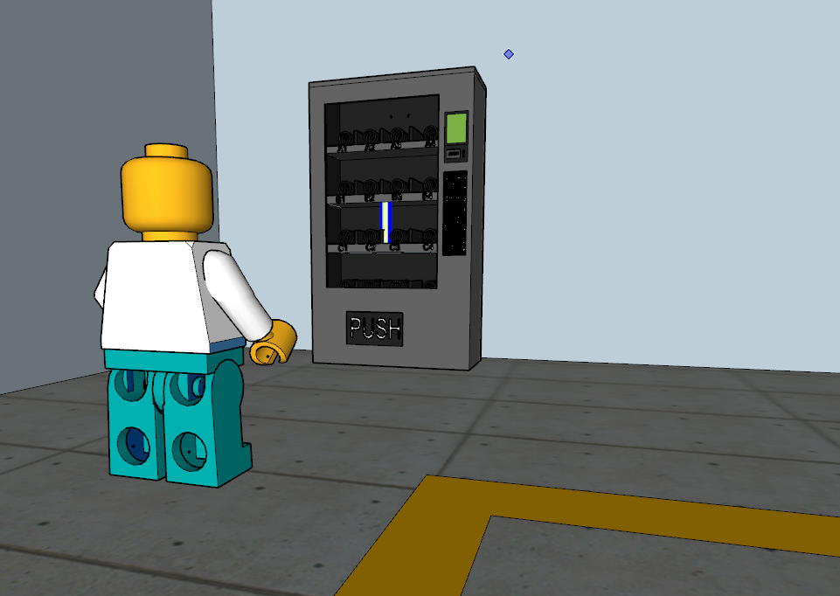

- Bart can paint new lines at each start point to prevent robot groups patrolling near by and preventing the player from completing the doors.
- Some of the door puzzles require this mechanic.
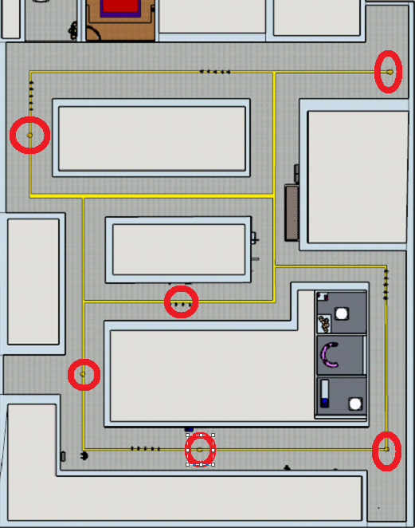

A
- Lisa uses her Laser Pen on the Laser target to reveal the target on the right.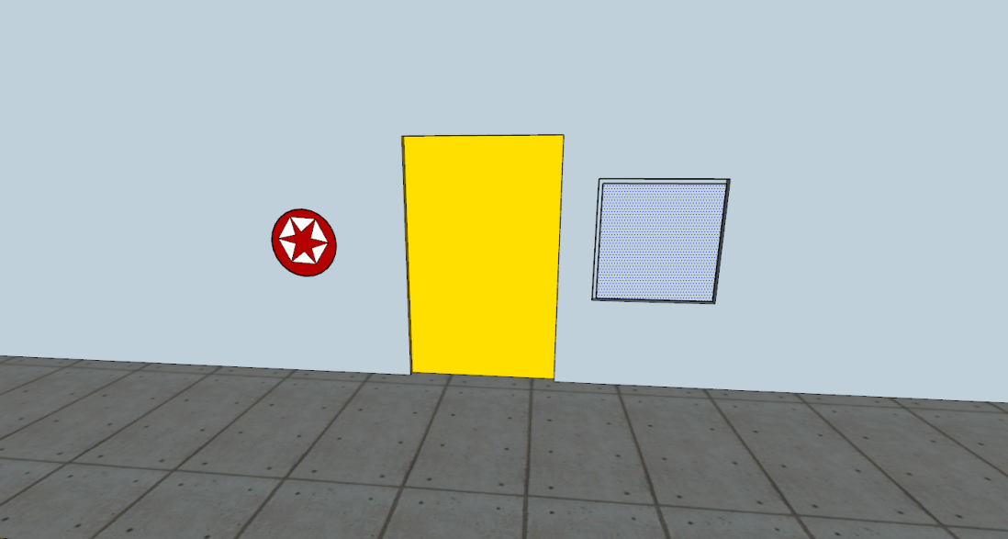
- Then Bart uses his Slingshot on the new target. And to door is jammed shut.
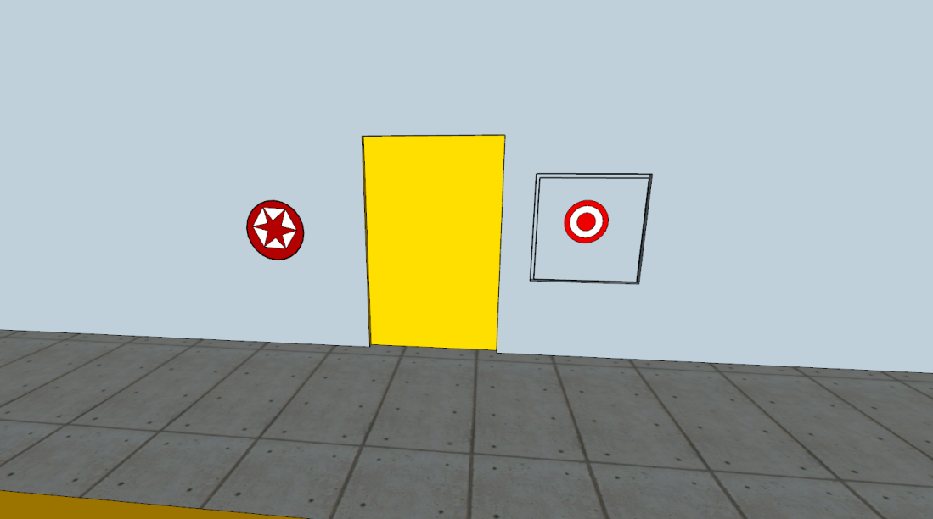

B
- The two vending machines are broken creating Build-it Pieces
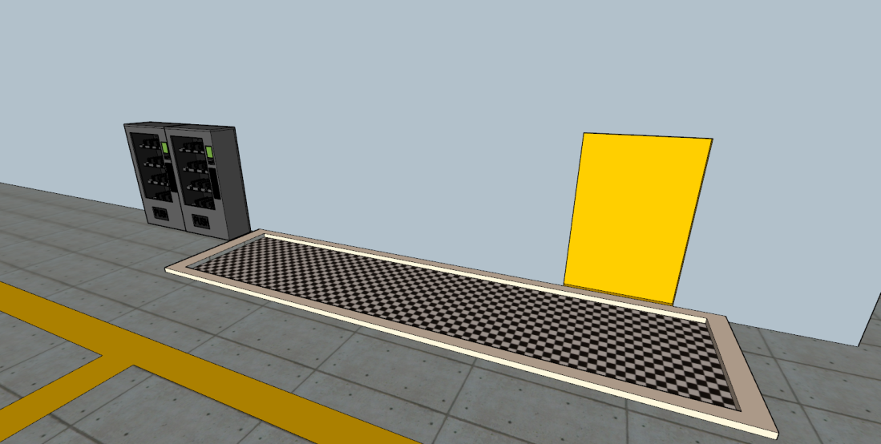

- The pieces create a large blockade on the track to the right.
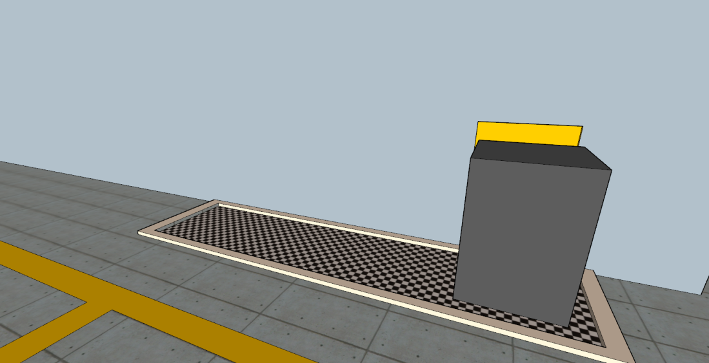

C
- Bart uses his agility to climb the piping and jump over to the swing pole, then onto another pipe that holds electrical wires.
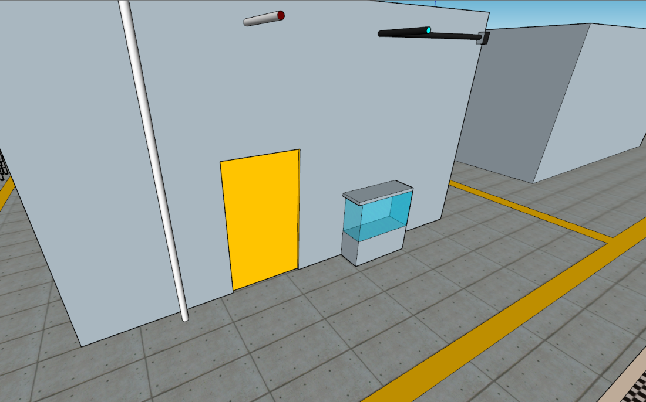
- The Piping then falls near the door, and the fish tank can be broken to create a puddle, this short circuits any robots coming out of the door.

D
- Homer must find another Uranium Rod to use in the Uranium Switch to extend some ledges to the right. At the same time, Bart uses the ledges to climb up and jump onto the pipe which then swing down and "locks" the door
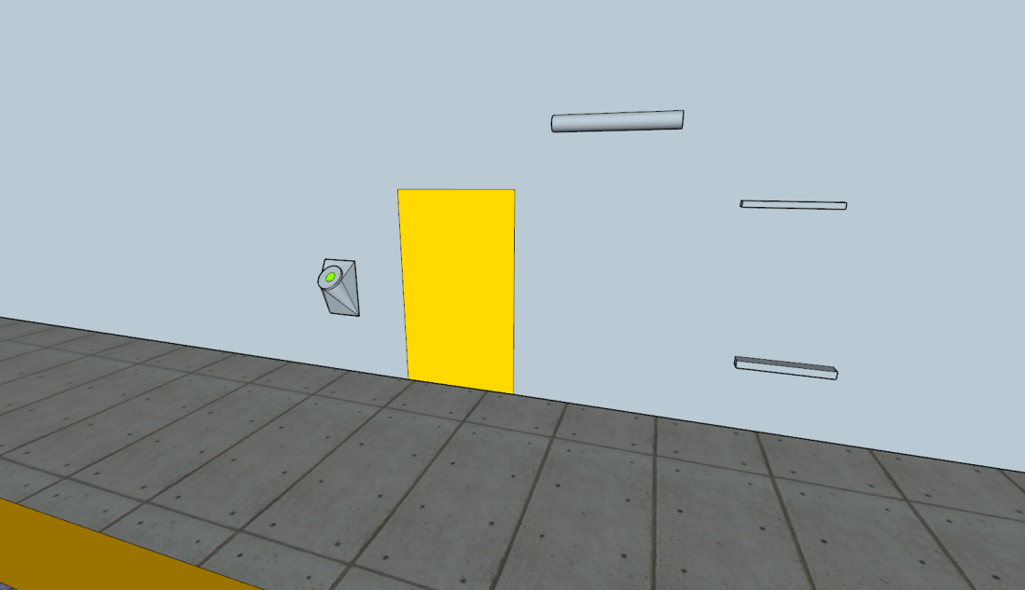

E
- Bart is used to paint a new yellow line towards the window, any robots will now follow this new line as priority and fall through the glass.
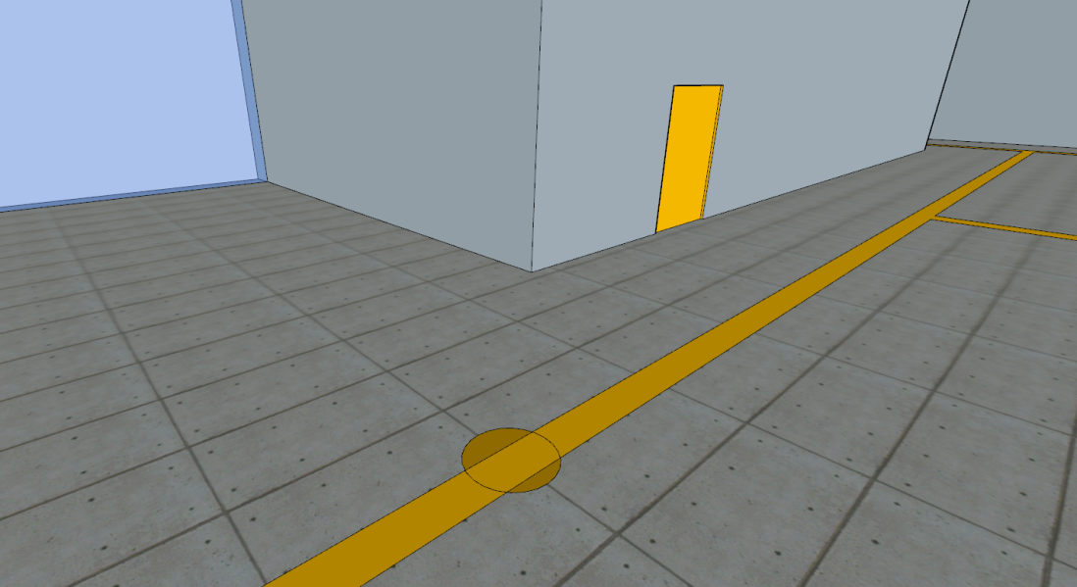
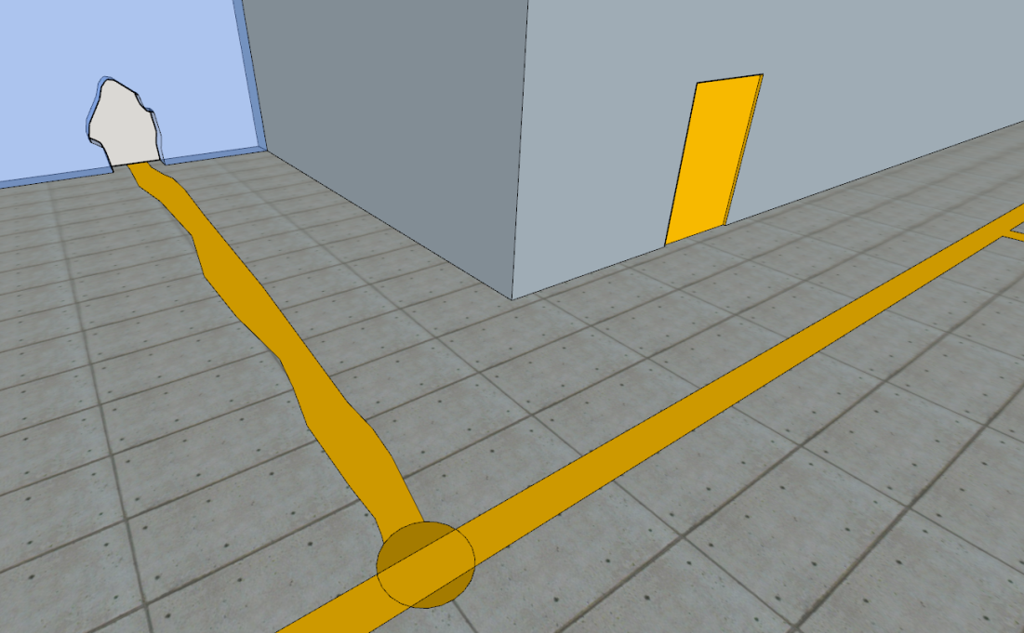

F
- Lisa uses the computer to hack the door and lock it open. Bart uses the paint to lead robots into the furnace
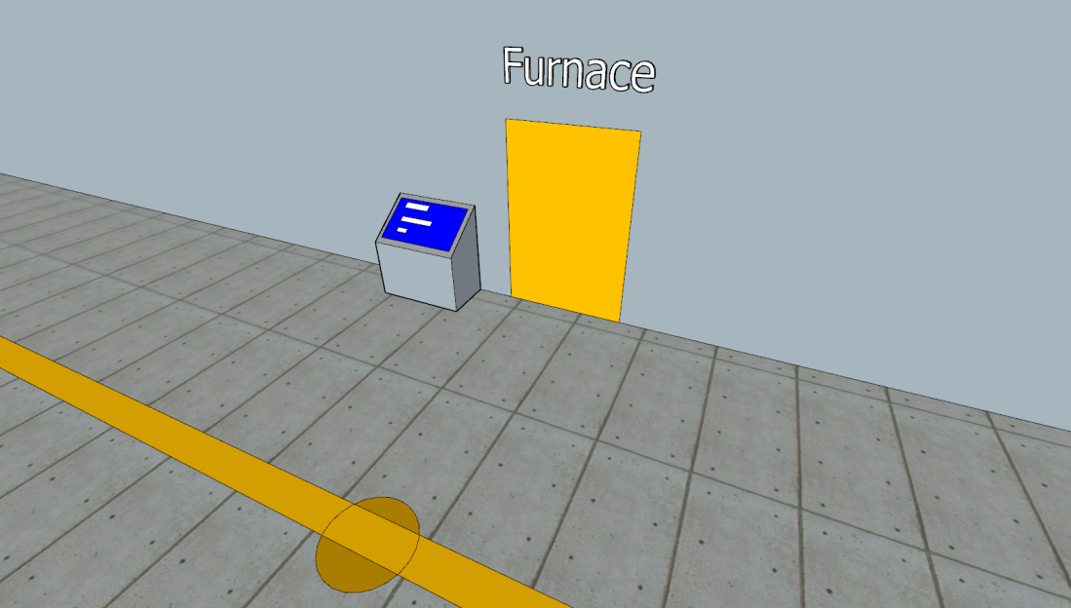

G
- Homer must use the Uranium Switch to lock the door closed. There is a Uranium Rod hidden in destructible props near the window to the left. If Bart uses the Paint that leads towards the window, the props can be broken by the next robots that follow that line.
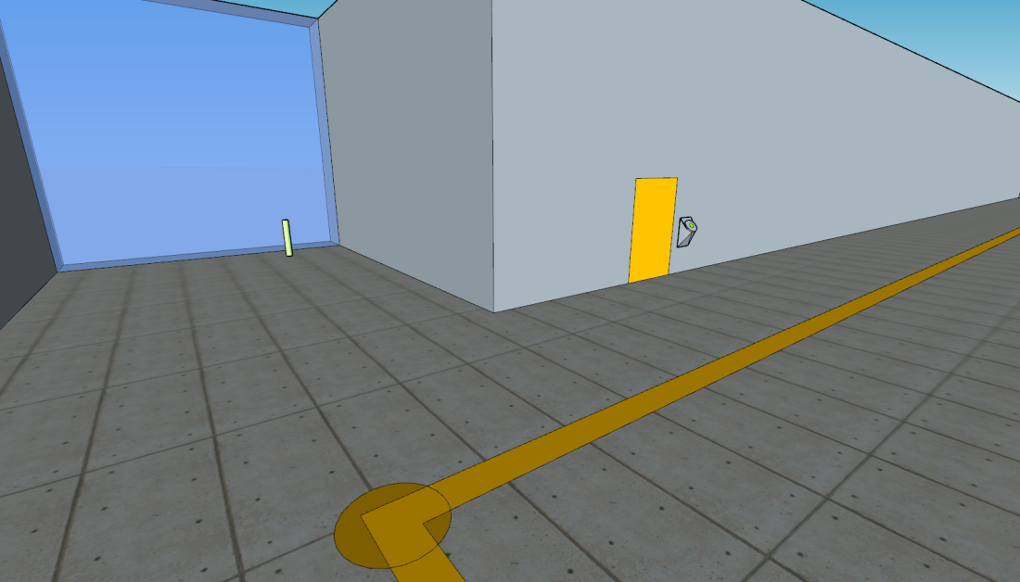

- After all doors puzzles are complete, the player must free Mr Burns and Smithers.
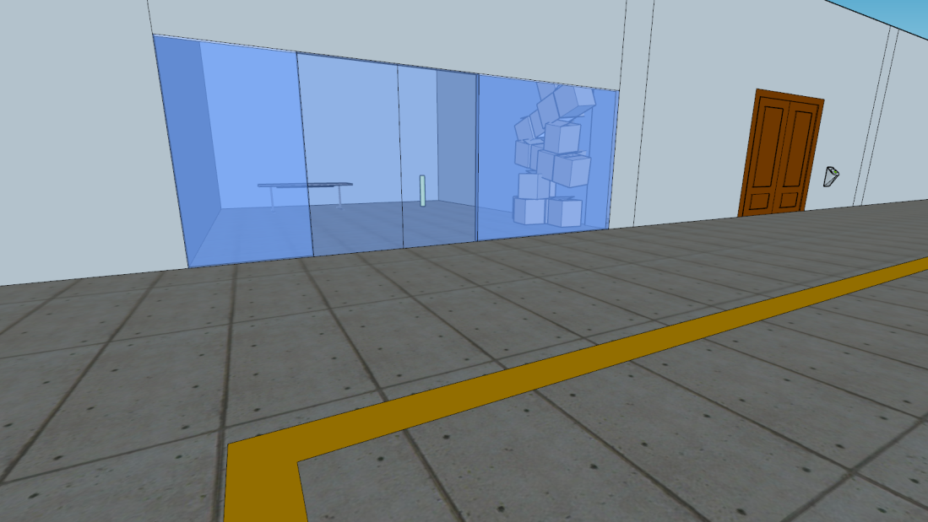
- As the player approaches the glass, Mr Burns walks over to the window and questions 'what took Homer so long?' and 'to get one with freeing him' while waving his arms.
- As Mr Burns waves his arms, he catches some boxes (props) nearby and they fall over to reveal a Laser Panel.
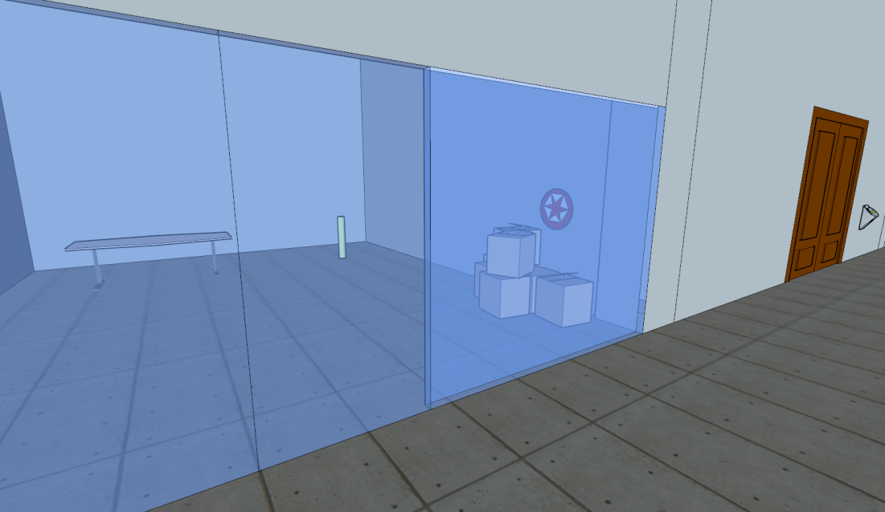
- While Lisa opens the door with the Laser Pen, Homer can enter and grab the Uranium Rod
- Homer can then use the Uranium Switch to open Mr Burn's office.
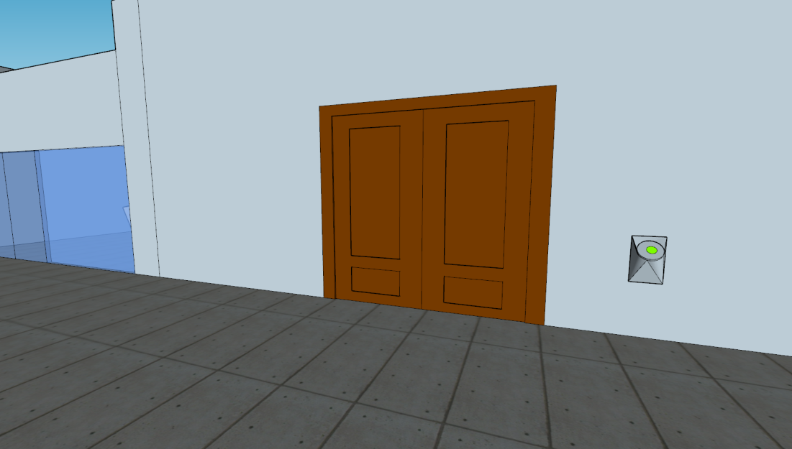

Stage 3 – Mr Burn's Office
- Now Mr Burns and Smithers are playable characters in the party, and the gameplay shifts slightly to allow the player to use their mechanics in this section.
- A Minicut is cued when players enter the office, showing the "boss". The prototype A10k Robot with the following:
  - Can create an electrical "wave" preventing players approaching it.
  - Laser eyes that have a 40 second recharge
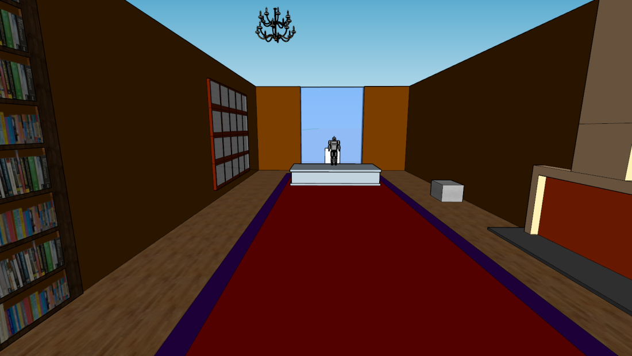
- Waves of 4 'regular' robots enter the room from "secret" doors next to Mr Burn's desk.
- The player must defeat these waves and avoid the "boss's" Laser attack.
- The "Boss" Must be attacked 3 Times to complete the level.
- As Mr burns cannot fight due to being weak he must summon his pack of dogs.
- Mr Burns can Use the Trap Door's scattered around the floor of the office to defeat the robots.
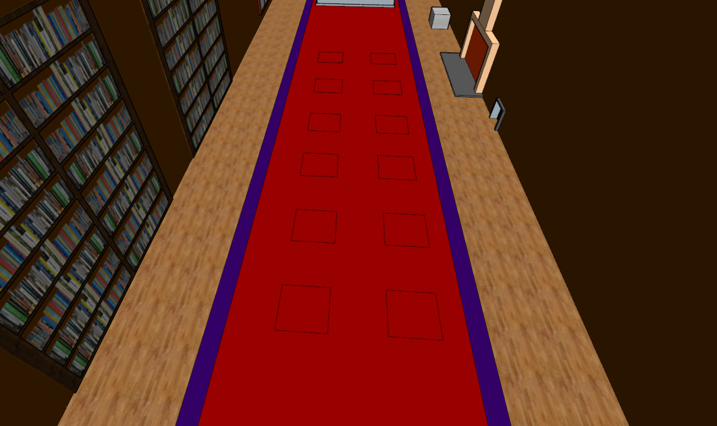

Attacks of the Boss:
- Chandelier
  - Bart must climb the bookcase to the left to access the ledge above
  - Once up there the video cable for Mr Burn's wall of monitors needs to be reconnected.
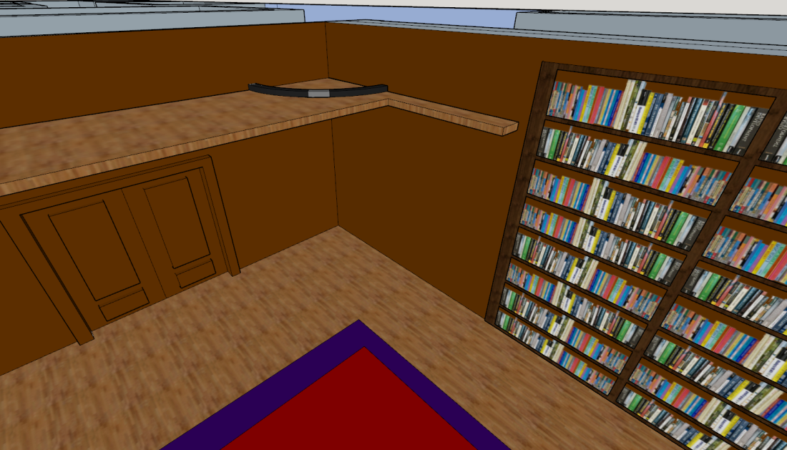
  - Doing so will distract the "boss".
  - Then Bart can target the Chandelier above and drop it, landing one hit on the A10K.
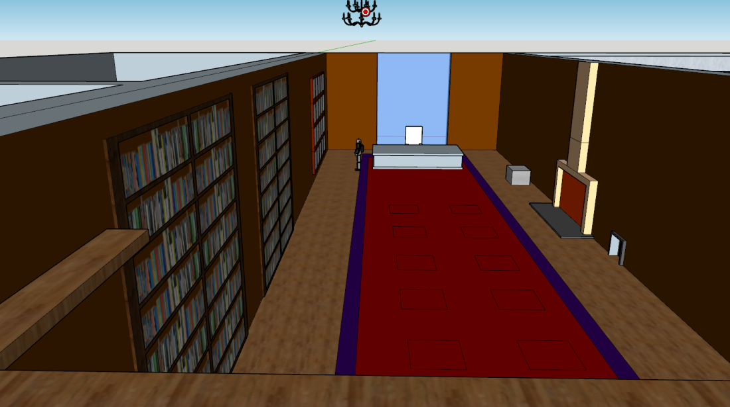

- Sprinklers
  - Smithers deploys his remote control Malibu Stacy car and drives it through the small vent on the right (this vent is too small for Bart or Lisa to crawl through)
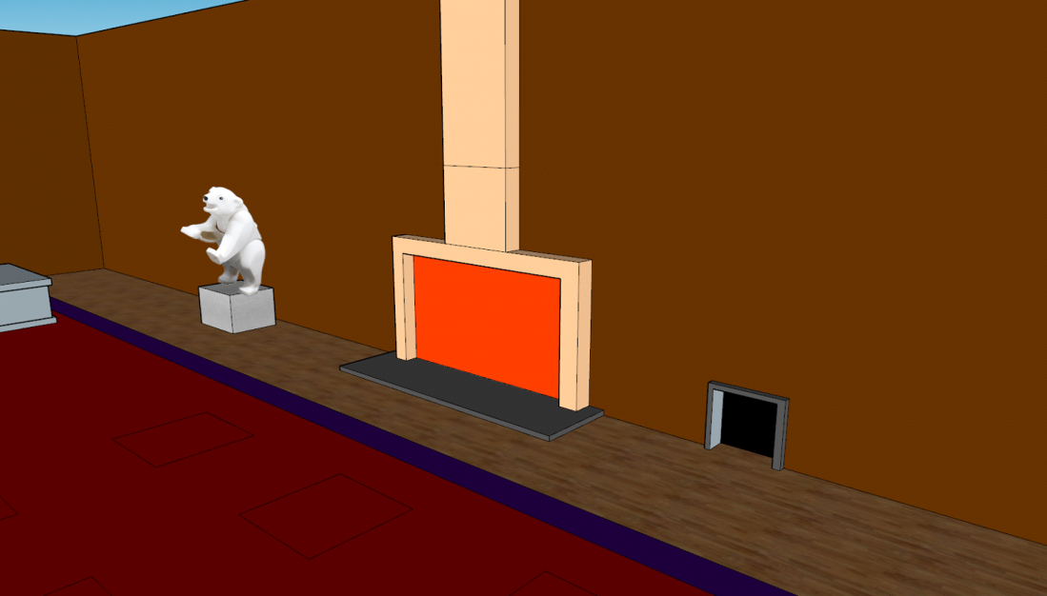
  - Once in the safe room, the car must use the props as a ramp to jump onto the desk, then jump again off the desk knocking over stacks of money, which fall and press the "open door" button.
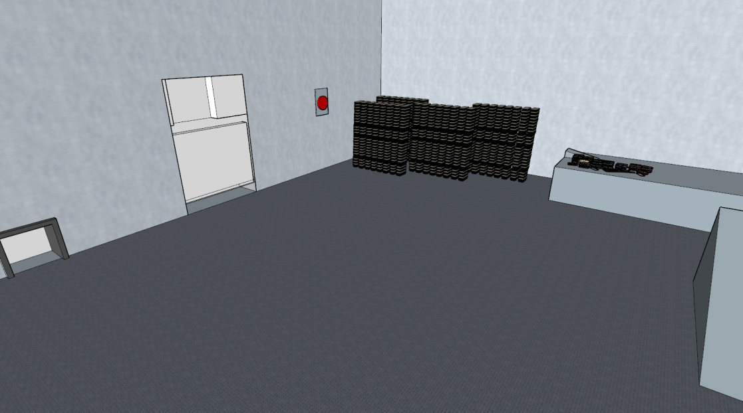
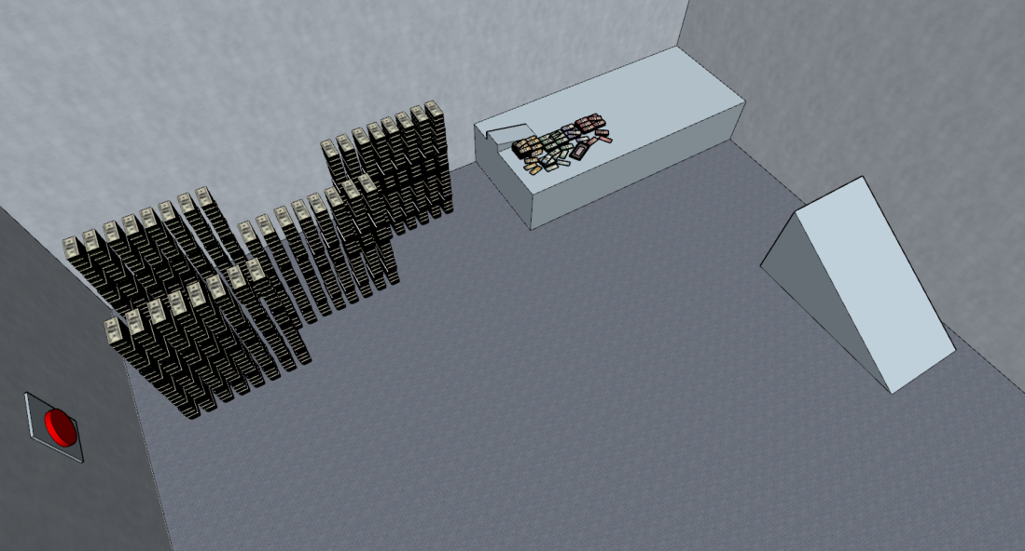
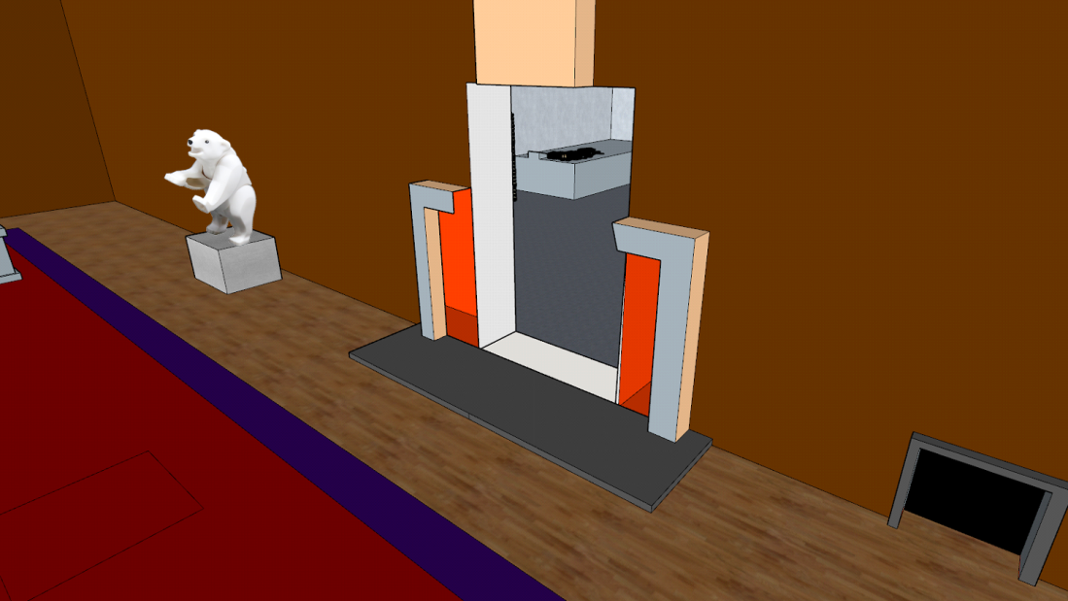

  - Smither or Lisa can then run inside and solve the whiteboard, to figure out what button to press. Pressing the buttons before solving the equation does not cause any damage to the "Boss".
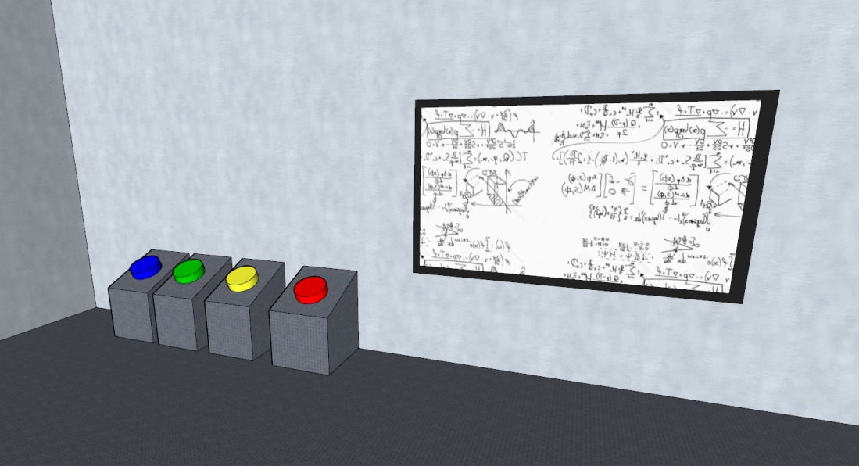
  - When the button is pressed, sprinklers are deployed in Mr. Burn's office which short circuit the "boss"

- Bear Attack
  - After the Second attack the A10K's 'core' starts to overheat after each Laser attack, when this happens players are able to approach the robot and attack it personally.
  - The Robot gives of another electric blast after it's cooled down pushing the characters back away.
  - The robot moves down in front of Mr. Burn's desk
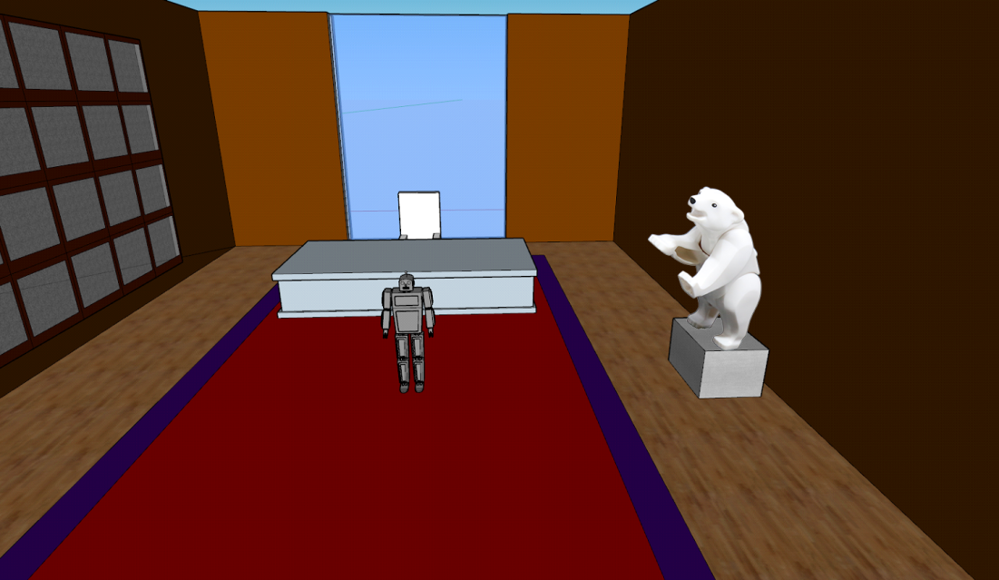

  - Mr. Burns can now use the Trap Door mechanic to trigger the bear statue.
  - Camera Zooms in to a quick-time event of the two wrestling and fighting.
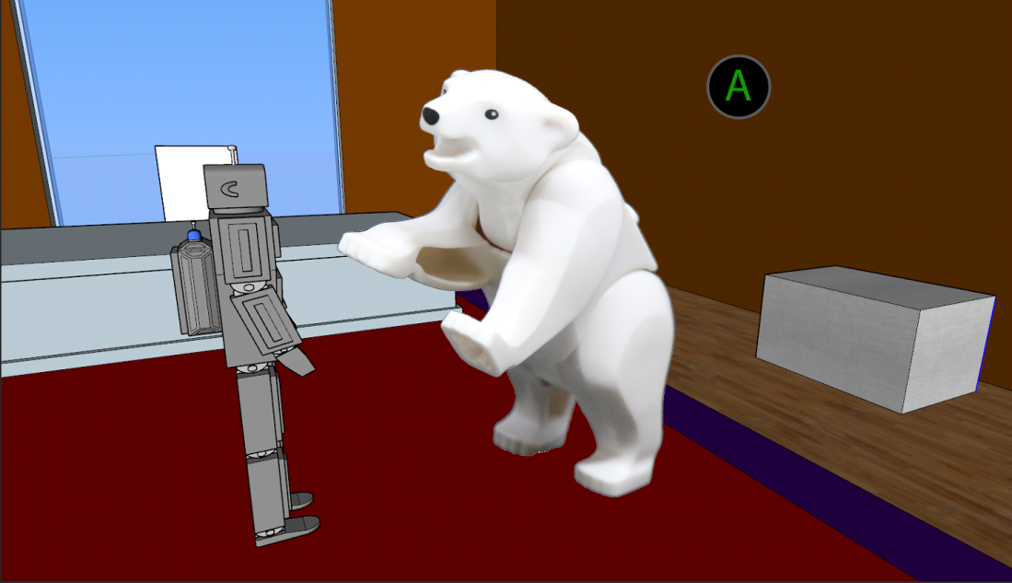
  - When the player completes the button prompts the level is complete and the outro cutscene is triggered

The outro cutscene shows the group leaving the power plant and many robots still walking out of the windows and into the furnace.

Co-op

The gameplay has been designed with Co-op play in mind. There is always something for a second player to do at the same time as player 1. Be it the doors in homers office, the switches and targets in the halls, or the attacks on the "boss".

Collectibles

There are several collectable Buzz Cola items throughout the level, which the player can collect for a reward.
- In the safe room at the side of Mr. Burn's office there is a stack of food that Homer can eat to lower the Buzz Cola.
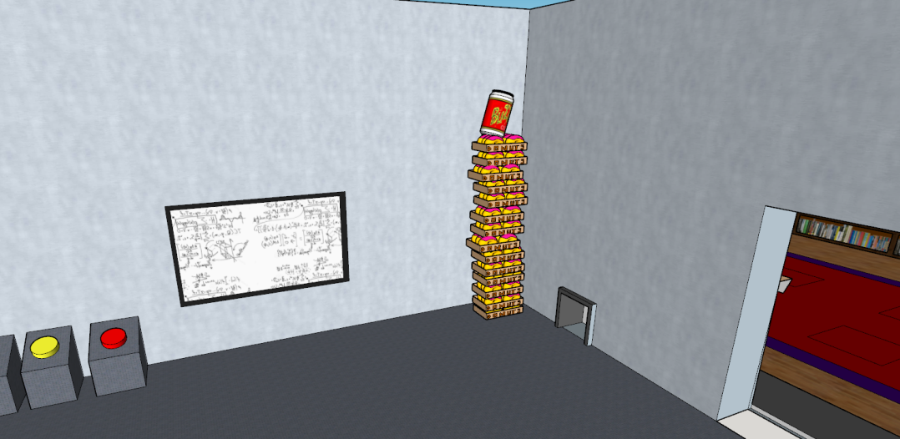
- Under a table in the room where Mr. Burns and Smithers were trapped
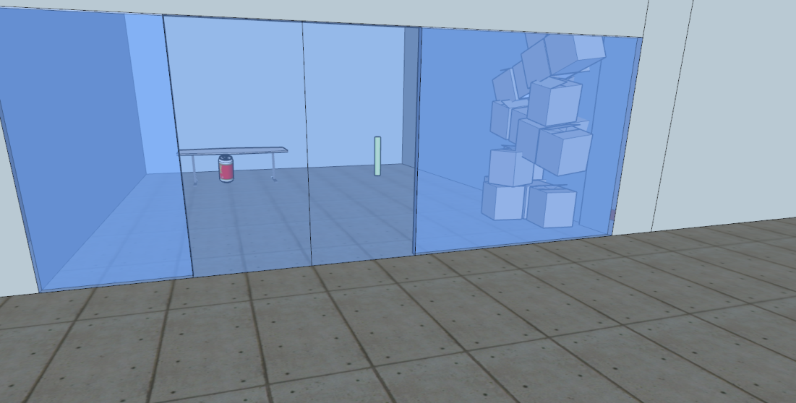

- Using every button on Homer's Desk.
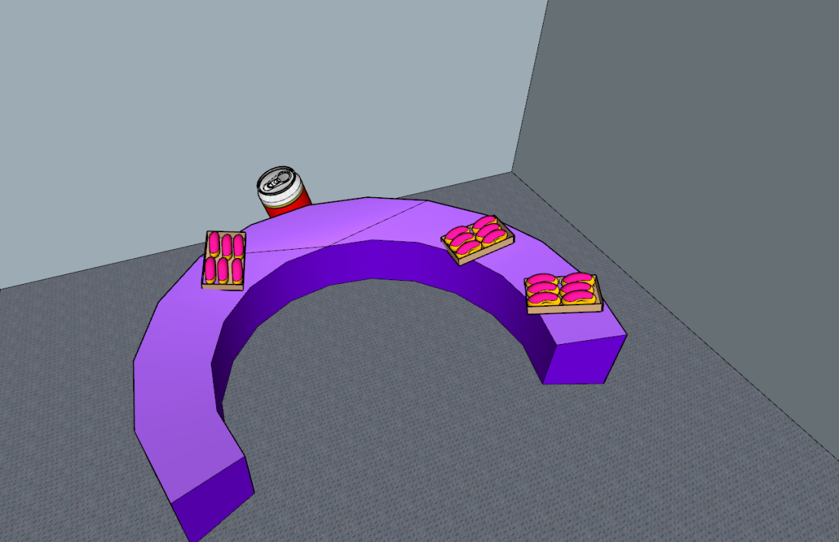
- Left of the high ledge where bart climbs to connect the video cable.
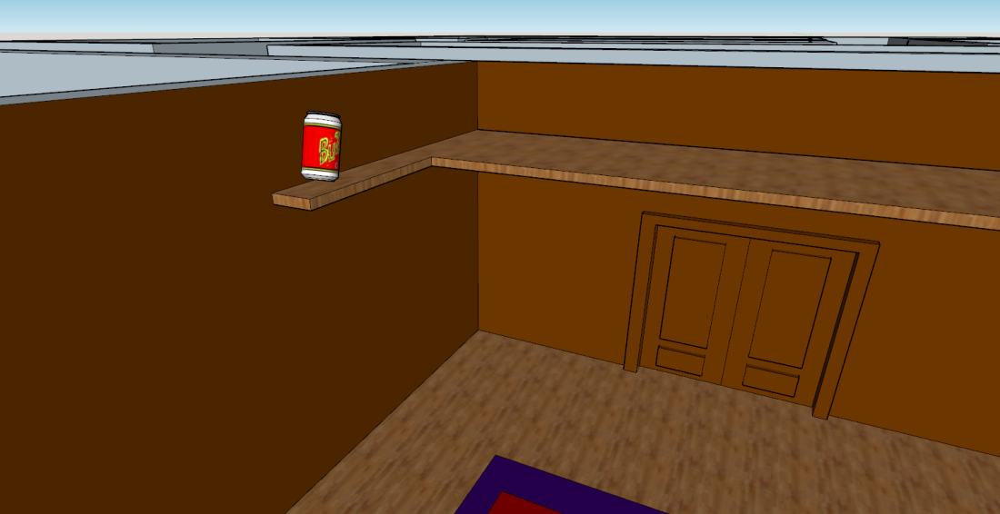

Congratulations you reached the end!

There's nothing more down here...

Apart from this Simpsons fact:
It took Danny Elfman just two days to compose The Simpsons’ famous theme in 1989.

